EX NO:04
DATE:
UK BANK DATA ANALYSIS

AIM: To analyze UK bank transaction data using Tableau by creating map, pie, histogram, and treemap visualizations to understand regional transaction distribution, gender-wise transactions, age and balance distributions, and job-wise transaction activity. To combine all visualizations into an interactive dashboard using action filters for effective data analysis and decision-making.
Problem Statement: You have been hired by a Bank that is currently operating in United Kingdom. The bank has asked you to help them to ease the process of analyzing its data. The management has provided with a few queries for you to solve.

- Create a Map chart showing the number of transactions processed in each region.
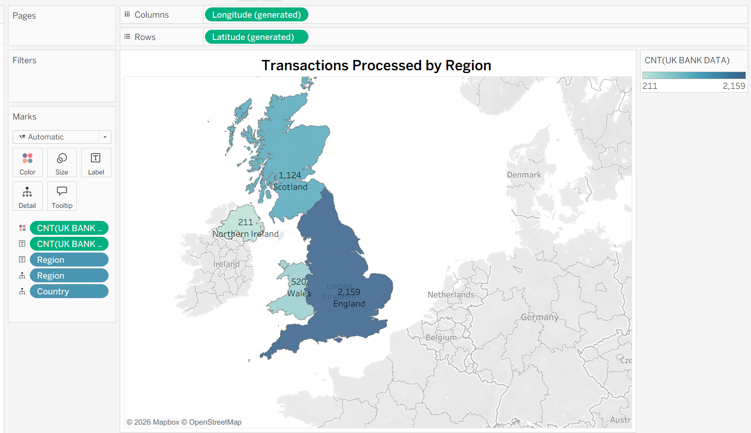

INTERPRETATION: The map chart displays the number of transactions processed in each region of the United Kingdom. It helps identify regions with high and low transaction activity and understand the geographical distribution of banking transactions. This information enables the bank to identify regions with greater customer activity and plan its services accordinglY

- Create a Pie chart displaying the percentage of each transaction processed between genders.

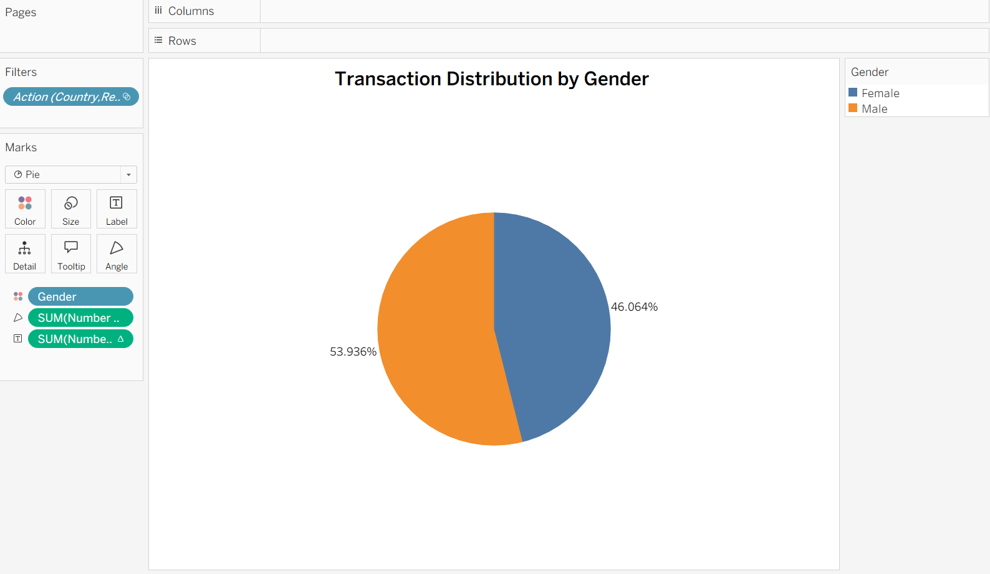

INTERPRETATION: The pie chart represents the percentage distribution of transactions between male and female customers. It helps compare transaction activity across genders and identify which group accounts for a larger share of the transactions. The bank can use these insights to understand customer activity and plan suitable banking services.

- Create a Histogram displaying the distribution of age and transactions processed.

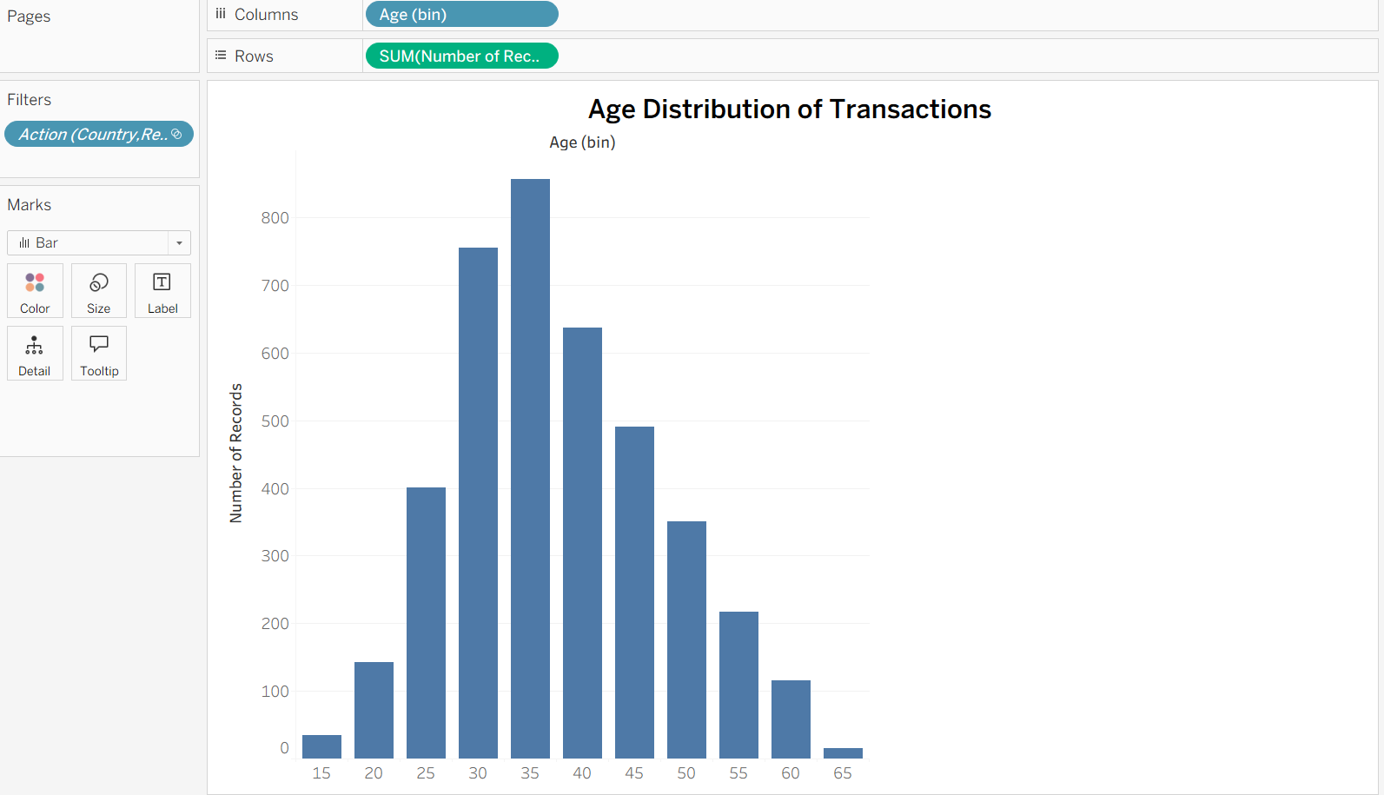

INTERPRETATION: The histogram displays the distribution of customer ages in relation to transaction activity. It helps identify the age groups with higher and lower transaction frequencies and understand which customer segments use banking services more actively. This information can support customer segmentation and targeted service planning.

- Create a Histogram displaying the distribution of balance and transactions processed.

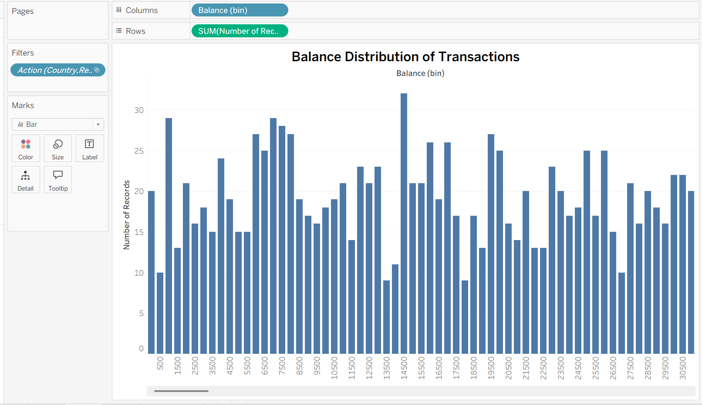

INTERPRETATION: The histogram shows the distribution of customer account balances in relation to transaction activity. It helps identify the balance ranges in which customers are concentrated and examine transaction patterns across different balance levels. This analysis can help the bank better understand its customers' financial profiles and banking activity.

- Create a Tree-map displaying the number of transactions processed within the classification of each job.

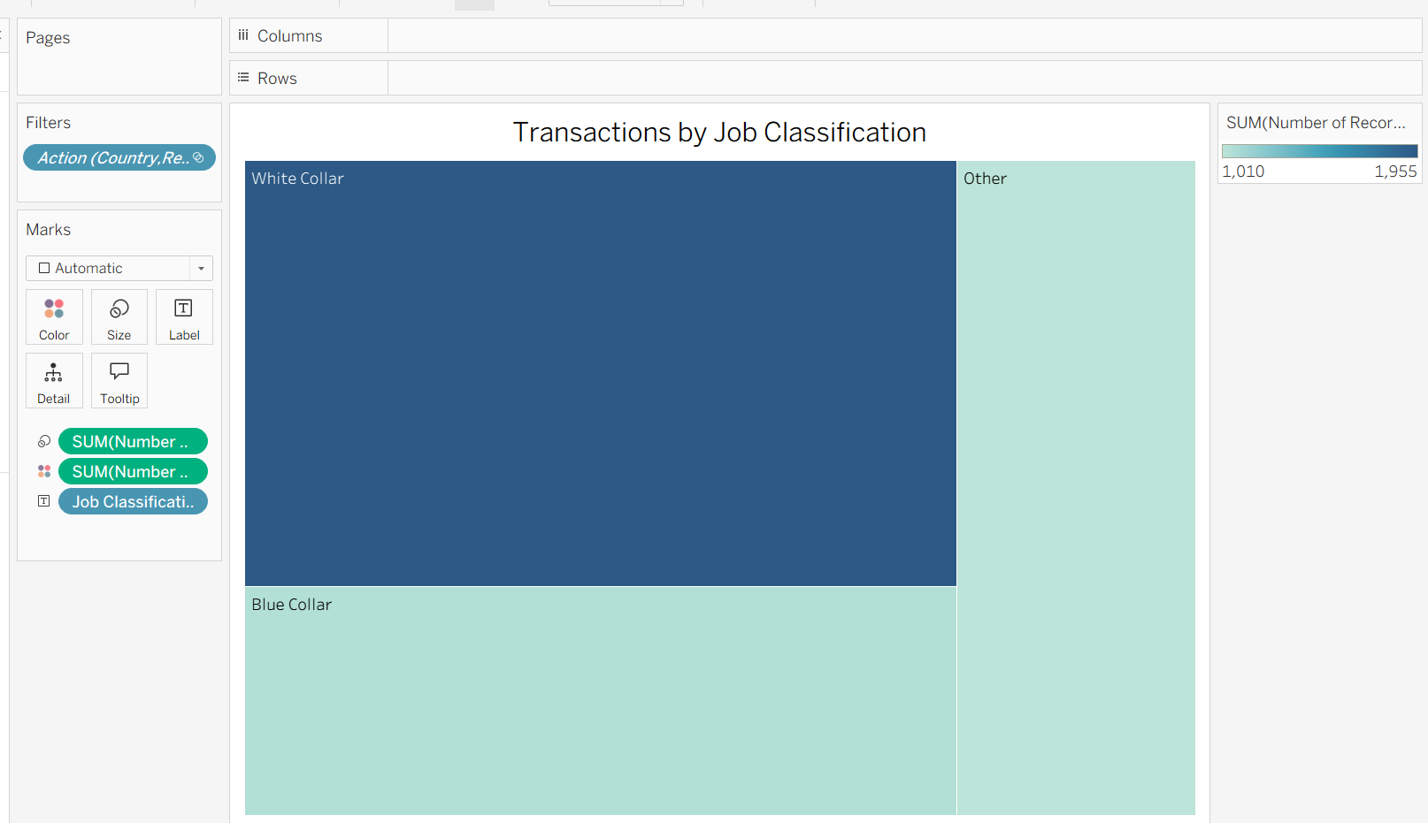

INTERPRETATION: The treemap represents the number of transactions processed across different job classifications. The size of each rectangle indicates the relative transaction activity associated with each job category. It helps identify occupational groups with higher and lower transaction activity, supporting customer segmentation and targeted banking services.

Create a Dashboard using all the charts. Make use of Action Filters as it will further improve the analyzing experience for the management. (Refer to the dataset from the file:UK BANK DATA.csv)

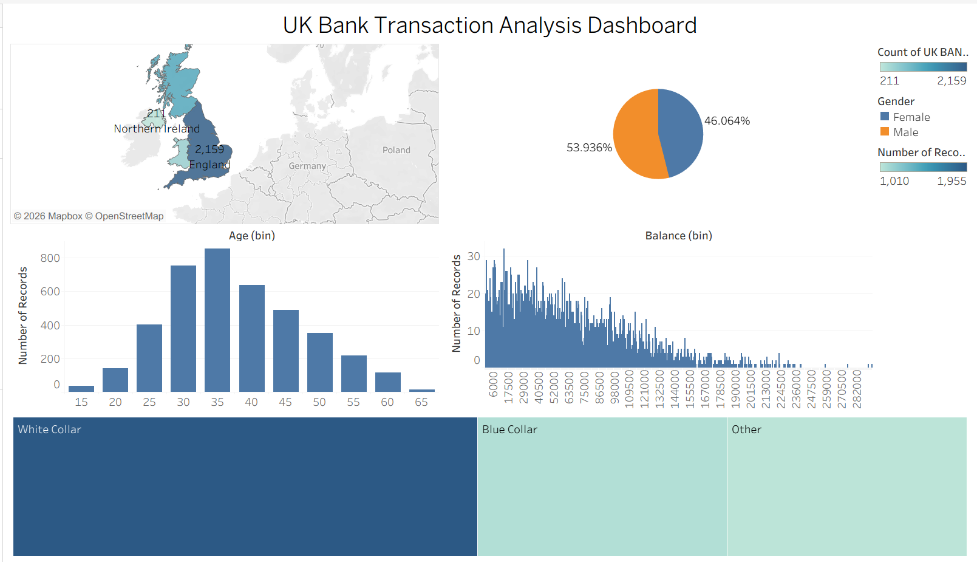

INTERPRETATION: The dashboard combines all five visualizations into a single interactive view. Action filters allow management to select a region, gender, age group, balance range, or job classification and examine the corresponding transaction patterns across the charts. This interactive approach makes it easier to compare customer segments, identify trends, and make informed decisions about banking services and customer engagement.

